ARMED ROBBERY / AGGRAVATED ASSAULT

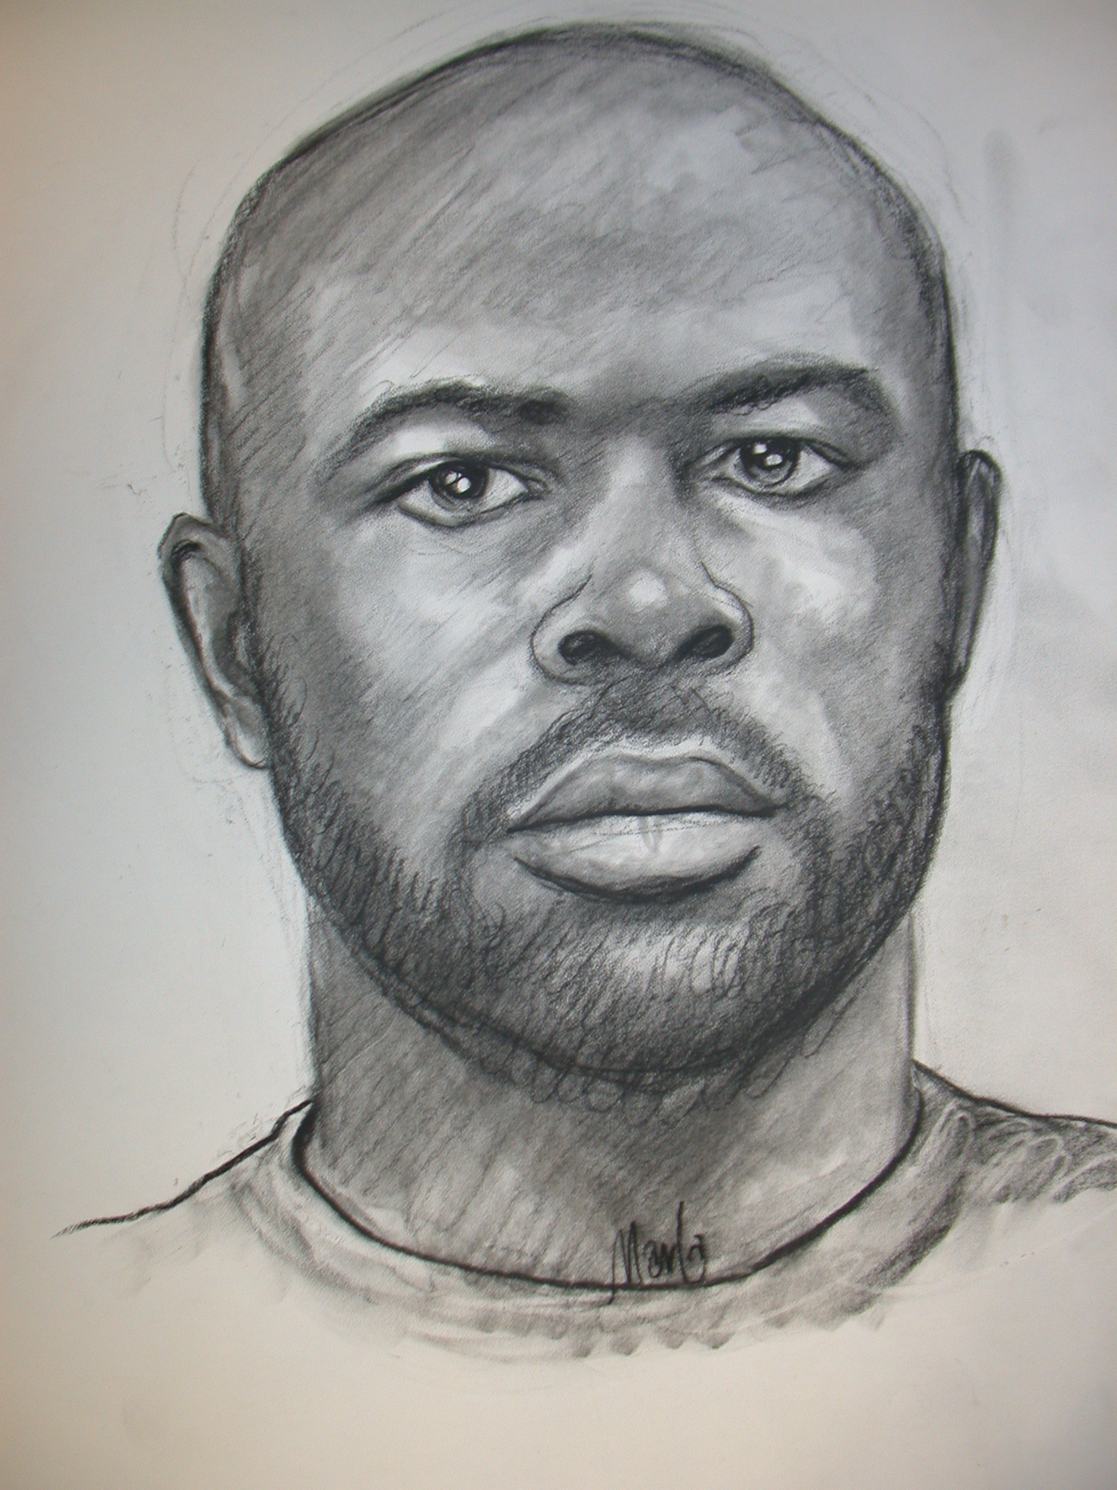
ON APRIL 13, 2006, A HOMEOWNER INTERRUPTED A BURGLARY IN PROGRESS AT HIS RESIDENCE ON STATE HWY. 203 IN SOUTHERN APPLING COUNTY, GEORGIA, AND WAS ROBBED AND SHOT BY THE OFFENDER. THIS COMPOSITE SKETCH OF THE PERPETRATOR WAS PREPARED FROM INTERVIEWS OF WITNESSES.

10 - 0 USE EXTREME CAUTION 10 - 0
ANYONE WITH INFORMATION OF THE ABOVE INDIVIDUAL, CONTACT:

Appling County Sheriff’s Office or Georgia Bureau of Investigation (912) 367-8120 S/A Tony Banks
(912) 389-4103

GBI Tip Line: 800-597-TIPS (8477)

